86th Annual
Commencement

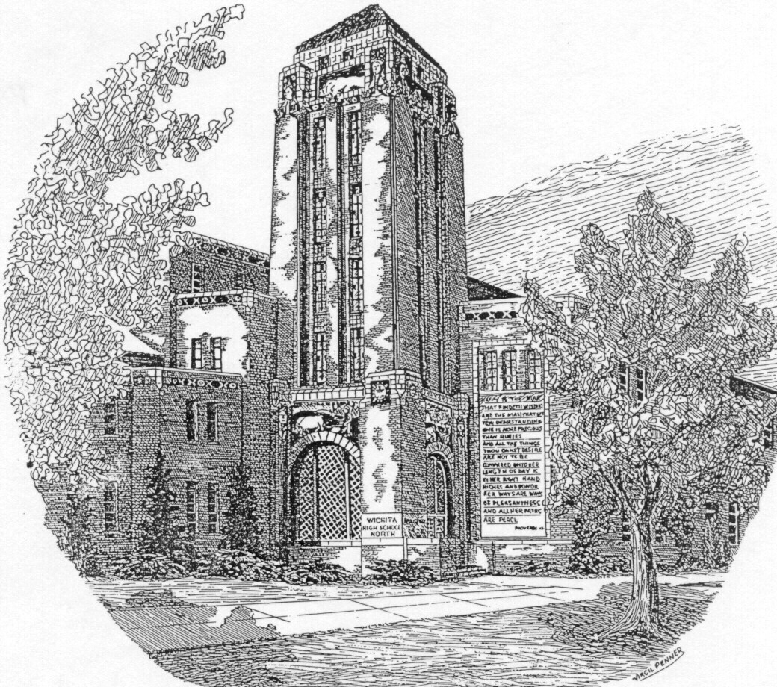
Koch Arena
Monday, May 11, 2015
Seven O’ clock

Wichita High School North
Program
Sherman Wm. Padgett
Principal, Wichita High School North, Presiding

PRELUDE Music Provided by
Symphonic Band
Processional “Pomp and Circumstance”……………………Edward Elgar, Composer
Symphonic Band
Stephanie Byers, Director
Audience please stand during processional
WELCOME Conner Christian
Lourdes (Vicky) Ibarra
PRESENTATION OF COLORS Redskin Battalion Color Guard
PLEDGE OF ALLEGIANCE Cadet Lieutenant Colonel Rebecca Dominick
“Star Spangled Banner” North Madrigal Singers
You may be seated
COMMENCEMENT ADDRESS Emilio A. Escamilla
“A Parting Blessing” Madrigal Singers
COMMENCEMENT ADDRESS Vanessa Gonzalez
GREETINGS FROM THE BOARD OF EDUCATION Lynn Rogers
SENIORS CLASS VIDEO PRESENTATION Senior Students
PRESENTATION OF CLASS Sherman Wm. Padgett
ACCEPTANCE Lynn Rogers
PRESENTATION OF DIPLOMAS Lisa Orsak
Carlos Cottner

Please stand for the singing of the North High Alma Mater.

Alma Mater
(Tune: Halls of Joy)
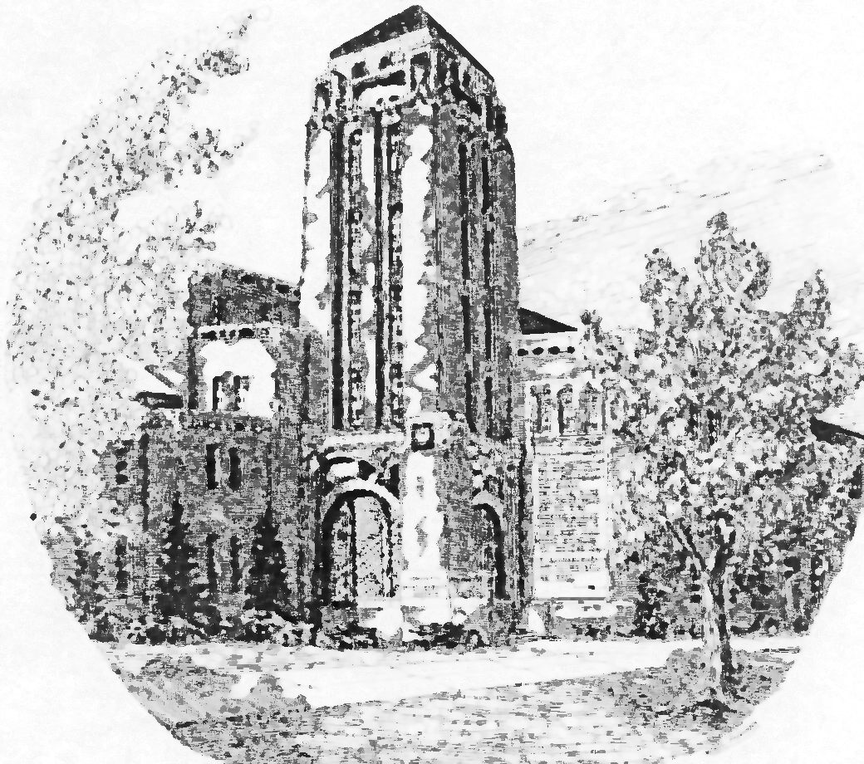
Within the walls of North High
that surround us here today.
Dwell all our fondest memories
though we’re far, far away.

The splendor of her structure
conceals with the rich disguise,
an even greater beauty,
which deep within her lies.

The friendships that we’ve made here,
live on though we’ll depart,
the good times shared together,
forever warm each heart.

Her river and her tower,
symbolic still shall be,
her beauty and her splendor
remain for all to see.

Charles Habernigg, 1950

VALEDICTORIAN Jaci Ignudo

Kansas Designated Board of Regents Scholars

Conner J. Christian
Rebecca L. Dominick
Jaci A. Ignudo
Phong B. Le
Selby R. Merrow

Kansas Board of Scholars

Yezenia Acosta
Enrique Alvarado Corral
Mauricio Alvarez
Brittany Bailey
Karla Baltazar
Ricardo Banuelos
Jesus Banuelos
Aliyah Bernard
Sarah Billings
Corey Blessman
Amanda Bullard
Eduardo Castillo
Hannah Cheatem
Jackson Cheek
Conner Christian
Sydney Climer
Hannah Coryea
Cody Couch
Gergana Daskalova
Renecca Davison
Mason Day
Alexandria Deblois
Rebecca Dominick
Erika Dubois
Diana Espino
Shekinah Flores
Alexandra Galleguillos
Brett Gile
Heather Golden
Vanessa Gonzalez
Liliana Guerrero
Alexis Guzman
Andrew Hauff
Ernesto Hernandez
Sandra Hernandez
Aleeya Hubbard
Jaci Ignudo
Dohnovan Jackson
Jameson Jones
Michelle Karanu
Alexander Kimber
Anna Kindel
Phong Le
Jessica Lopez
Monica Lopez-Carrera
Abigail Marin
Blaine Martin
Dalia Martinez
Guadalupe Del Rosario Martinez
Aron Martinez
Melissa Martinez
Yesenia Martinez Del Real
Alina Mendoza
Caylee Merrow
Shelby Merrow
Erika Montelongo
Quynh-Nhu Nguyen
Deisy Ornelas
Jennifer Paredes-Aquilera
Kayla Rains
Jonathan Roach
Alondra Rodarte
Evan Ruckle
Stephanie Ruiz
Alicia Ryan
Sami Sabrah
Alexis Saldana
Christian Saldana-Banuelos
Erika Sanchez-Sanchez
Zephra Santhiapillai
Samuel Schmidt
Joseph Schmitt
Christian Soto-Lopez
Cirilo Stumblingbear
Lessly Talamantez
Christian Torres Montes De Oca
Vanessa Valenzuela
Anny Vo
Brittany Wilkerson
Haylee Williams
Austin Wilson
Ricardo Zapien
Jessica Zavala

Kansas Board of Regents Qualified Admissions

Yezenia Acosta
Adela Acosta
Enrique Alvarado Corral
Mauricio Alvarez
Stefany Amezquita
Brittany Bailey
Karla Baltazar
Ricardo Banuelos
Jesus Banuelos
Vanessa Barraza
Juan Barron
Aliyah Bernard
Jesus Berumen
Sarah Billings
Moriah Bird
Corey Blessman
Keenan Bozeman
Amanda Bullard
Eduardo Castillo
Sirhan Chavarria
Hannah Cheatem
Jackson Cheek
Austin Christian
Joshua Christian
Conner Christian
Sydney Climer
Francisco Corral
Hannah Coryea
Cody Couch
Anna Dahlinger
Gergana Daskalova
Renecca Davison
Mason Day
Alexandria Deblois
Sean Denning
Rebecca Dominick
Erika Dubois
Dakota Ecklund
Jessica Emiliano
Johana Esparza
Marco Espinal
Diana Espino
Sonia Esqueda
Maxwel Flippin
Shekinah Flores
Alexandra Galleguillos
Sarah Garcia
Iliana Garcia
Ernesto Garcia
Brett Gile
Heather Golden
Maria Gomez
Vanessa Gonzalez
Rafael Granados
Liliana Guerrero
Tanaiciana Gunter
Alexis Guzman
Andrew Hauff
Ernesto Hernandez
Claudia Hernandez
Sandra Hernandez
Philip Hildebrand
Brent Houston
Aleeya Hubbard
Sahar Hudeib
Cathy Huynh
Itzel I Martinez
Jaci Ignudo
Dohnovyn Jackson
Hazel Jay-Nesahkluah
Cory Johnson
Emily Jones
Jameson Jones
Michelle Karanu
Alexander Kimber
Anna Kindel
Adreana Kendrick
KaNysha Kreie
Phong Le
Aaron Long
Jessica Lopez
Monica Lopez-Carrera
Arianna Lujano
Viviana Macias-Mijares
Erik Maldonado
Abigail Marin
Balente Marquez
Blaine Martin
Juliana Martinez
Dalia Martinez
Guadalupe Del Rosario Martinez
Aron Martinez
Melissa Martinez
Yesenia Martinez Del Real
Alina Mendoza
Yazmin Meraz
Caylee Merrow
Shelby Merrow
Ashley Meyer
Jorge Meza
Erika Montelongo
Marleah Mullen
Elizabeth Murphy
Quynh-Nhu Nguyen
Brandon Nguyen
Deisy Ornelas
Jennifer Paredes-Aquilera
Cynthia Quintana Perez
Kayla Rains
Anllir Ramirez Tenorio
Maurisha Reid
Shaun Ring
Jonathan Roach
Alondra Rodarte
Evan Ruckle
Stephanie Ruiz
Alicea Ryan
Sami Sabrah
Alexis Saldana
Christian Saldana-Banuelos
Erika Sanchez-Sanchez
Zephra Santhiapillai
Jessica Santos
Samuel Schmidt
Joseph Schmitt
Savannah Shawnee
Zachery Somerville
Christian Soto-Lopez
Cirilo Stumblingbear
Lessly Talamantez
Christian Torres Montes De Oca
Melissa Tovar
Melissa Valdez
Vanessa Valenzuela
Anny Vo
Tiffany Voldrich
Ashley Walker
Shaley Walker
Toni Webber
Morgan Wheeler
Angela White
Dederick White
Brittany Wilkerson
Haylee Williams
Austin Wilson
Ricardo Zapien
Jessica Zavala

Scholars Bowl Seniors
Maxwell Flippin
Austin Wilson

Student Body Officers
President Alexander Kimber
Vice-President Jameson Jones
Senior Class Officer
President Jameson Jones
Vice-President Alexander Kimber

National Honor Society
The Honor Society members are wearing blue and gold honor cords.

Yezenia Acosta
Stefany Amezquita
Moriah Bird
Conner Christian
Joshua Christian
Hannah Coryea
Gergana Daskalova
Carly Dexter
Vanessa Gonzalez
Jaci Ignudo
Emily Jones
Jameson Jones
Alexander Kimber
Anna Kindel
Phong Le
Melissa Martinez
Yesenia Martinez
Caylee Merrow
Selby Merrow
Ashley Meyer
Jennifer Paredes-Aguilera
Kayla Rains
Christian Torres Montes De Oca
Anny Vo
Haylee Williams

AVID Students of Distinction
The AVID graduates are wearing blue and silver honor cords.
AVID Students of distinction are wearing white stoles.

Guadalupe Andrade
Brittany Bailey
Karla Baltazar
Stephanie Briceno
Gergana Daskalova
Alondra Garcia
Brett Gile
Vanessa Gonzalez
Sandra Hernandez
Jameson Jones
Chanclee Killough
Jessica Lopez
Guadalupe Del Rosario Martinez
Yesenia Martinez Del Real
Brandon Nguyen
Nhu Nguyen
Jenny Paredes-Aguilera
Kayla Rains
Karla Rodriguez
Stephanie Ruiz
Alicia Ryan
Christian Torres Montes De Oca
Vanessa Valenzuela
Anny Vo

Sociedad Honoraria Hispanica
The Spanish Honor Society members are wearing red and gold honor cords.

Karla Baltazar
Moriah Bird
Conner Christian
Hannah Coryea
Anna Dahlinger
Gergana Dasklova
Jessica Emiliano
Ilse Garcia-Gonzalez
Andrew Hauff
Phuong Le
Yesenia Mendez Vazquez
Erika Montelongo
Haley Plamann
Alondra Rodarte
Jareli Rosas
Stephanie Ruiz
Erika Sanchez
Austin Wilson

Quill and Scroll Journalism Honor Society
Quill and Scroll members are wearing blue and gold honor cords.

Rebecca Davison
Zephra Santhiapillai

Candidates for Graduation Class of 2015

Da’chell C. Abram
Adela M. Acosta
Yezenia A.Acosta
Johnny A. Adame
Alfredo Aguilar
Athziry M. Aguilar
Sally A. Aguilar
Zyesha Y. Allen
Enrique A. Alvarado Corral
Lesley L. Alvarez
Mauricio R. Alvarez
Evelyn M. Amezquita
Stefany M. Amezquita
Jose G. Amparan
Jose E. Anaya
Alicia M. Anderson
Guadalupe C. Andrade
Ashley A. Arango
Adriana R. Avelar
Brittany r. Bailey
Karla Baltazar
Brenda V. Banuelos
Jesus Banuelos
Joseph M. Banuelos
Ricardo Banuelos
Vanessa Barraza
Juan A. Barron
Denise R. Bashline
Amber M. Berggren
Aliyah L. Bernard
Ernesto A. Berumen
Jesus G. Berumen
Sarah A. Billings
David A. Bird
Moriah A. Bird
Alec C. Black
Corey R. Blessman
Marcos V. Bocanegra
Keenan J. Bozeman
Kajabria S. Brazil
Stephanie V. Briceno
Jazlyn Brooks
Amanda J. Bullard
Irvin A. Caballero
Asuzena Campa
Leslie B. Campos
Hannah J. Carlson
Juan S. Carrera
Jordan T. Carroll
Johneice E. Carter
Juan Castellanos
Eduardo J. Castillo
Oziris E. Castillo Regalado
Jasmine B. Ceballos
Ricardo Chairez
Keandre T. Champion
Uau Chan
Sirhan Chavarria
Hannah K. Cheatem
Jackson T. Cheek
Zoe E. Childs
Austin A. Christian
Conner J. Christian
Joshua C. Christian
Sydney L. Climer
Lucero E. Contreras
Jordan L. Cooper
Maritza O. Cordero
Bianca G. Cordero-Zapata
Francisco Corral
Hannah N. Coryea
Cody J. Couch
Alycia R. Cox
Gabrielle R. Cranor
Maribel Cruz
Devin J. Culver
Anna L. Dahlinger
Gergana I. Daskalova
Rebeckha G. Davenport
Rebecca L. Davison
Mason E. Day
Alexandria R. Deblois
Alberto A. Jr Del Rio
Guillermo Delatorre
Sean A. Denning
Paul D. Dinh
Rebecca L. Dominick
Anisa L. Dozal
Erika I. Dubois
Vanessa I. Duenas
Matthew E. Dunagan
Kaitlynn J. Dunkel
Carleton D. Eagle Feather
Dakota C. Ecklund
Jessica Emiliano
Christian A. Escamilla
Emilio A. Escamilla Valdivia
Brisia R. Esparza
Johana Esparza
Marco A. Espinal
Diana L. Espino
Sonia Esqueda
Lauren Farris
Kala M. Fields
Preston T. Fisher-Plummer
Christopher Flemming
Maxwell D. Flippin
Diana L. Flores
Jacqueline Flores
Shekinah Flores
Alexis Jair Flores Mendez
Rosalia Fraire
Luis G. Fuentes
Jessica Galindo
Angela C. Gallegos
Miguel O. Gallegos
Alexandra T. Galleguillos
Miguelangel Gallo
Jamie L. Garancosky
Alondra Garcia
Antonio D. Garcia
Brenda Garcia
Ernesto Jr. Garcia
Iliana M. Garcia
Nancy V. Garcia
Sarah L. Garcia
Victor M. Garcia
Maria G. Garcia Hernandez
Tania L. Garcia Perez
Ilse J. Garcia-Gonzalez
Cristal Garcia-Ramirez
Jose M. Gaspar-Gonzalez
Samantha L. Geraci
Brett C. Gile
Heather B. Golden
Maria D. Gomez
Mario A. Gomez
Stephen A. Gomez
Alysia N. Gonzalez
Angel S. Gonzalez
Jonathan Gonzalez
Vanessa E. Gonzalez
Dakota T. Graham
Rafael Granados
Jabari Graves
Liliana B. Guerrero
Daisy S. Guevara
Tanaiciana R. Gunter
Hector J. Gutierrez
Shayla E. Guzan
Alexis Guzman
Gonzalo Guzman
Jacinto Guzman
Brock A. Hajek
Marcus R. Hampton
Destiney P. Harris
Tristan M. Hart
Andrew L. Hauff
Claudia Hernandez
Cynthia D. Hernandez
Ernesto G. Hernandez
Francisco J. Hernandez
Jose Hernandez
Lesly M. Hernandez
Lucero R. Hernandez
Sandra Hernandez
Susie Hernandez
Jon F. Herren
Joseph R. Herren
Alexis D. Herrera
Philip A. Hildebrand
Kamryn A. Honier
Brent A. Houston
Raymond D. Houston
Aleeya D. Hubbard
Sahar A. Hudeib
Jessie F. Hudson
Cathy Huynh
Steven T. Huynh
Adriana Ibarra
Ernesto Ibarra
Lourdes V. Ibarra
Jaci A. Ignudo
Dohnovyn W. Jackson
Mirjam M. Jacobson
Hazel E. Jay-Nesahkluah
Cory M. Johnson
Emily E. Jones
Jameson E. Jones
Michelle Karanu
Adreanna Kendrick
Blake A. Kenneson
Chanclee R. Killough
Alexander M. Kimber
Anna V. Kindel
Brandon M. Kohl
KaNysha Kreie
Ryan A. Laetari
Phong B. Le
Jesus Leon
Austin T. Letterman
Elida D. Leyva
Aaron A. Long
Jessica M. Lopez
Jorge A. Lopez
Roberto Lopez Garcia
Monica A. Lopez-Carrera
Casey J. Lough
Quinton B. Lough
Arianna J. Lujano
Stephany Lujano
Rosa I. Lumbreras
Viviana Macias-Mijares
Erik R. Maldonado
Jose M. Maldonado
Ronaldo Mandujano
David Mares-Vital
Abigail G. Marin
Jailene E. Marin
Balente Marquez
Blaine A. Martin
Alfredo A. Martinez
Aron Martinez
Dalia Martinez
Guadalupe Del Rosario Martinez
Itzel Martinez
Jesus E. Martinez
Juliana G. Martinez
Lourdes M. Martinez
Marco A. Martinez
Melissa C. Martinez
Sara C. Martinez
Yesenia Martinez Del Real
Tanya N. Martinez-Pena
Payton D. Massey
Darlene K. Matthews
Elisha L. McBride
Leanna M. McClurg
Lexine I. McElfresh
Morgan E. McFerren
Janet V. Medina
Yesenia Mendez Vazquez
Alina M. Mendoza
Yazmin Meraz
Caylee M. Merrow
Selby R. Merrow
Ashley E. Meyer
Jessica Y. Meza
Jorge A. Meza
Vanessa L. Meza
Emanuel Mijares
Brandon L. Miller
Alejandro A. Montanez
Erika Montelongo
Gloria J. Montes
Israel A. Morales
Giovanni Moreno
Christian Morga
Monique T. Morris
Marleah K. Mullen
Rocio Munoz
Viridiana Munoz
Karen J. Munoz-Gutierrez
Elizabeth V. Murphy
Danauel Murray
Janaizia J. Murry
Ray M. Murry
Arae C. Naden
Kevin T. Jr Nelson
Brandon Nguyen
Mi K. Nguyen
Quynh-Nhu T. Nguyen
Kasteele Nichols
Bailee D. Nichols-Clary
Emili Y. Norona
Delaney K. Northcutt
Stephanie L. Nutt
Brenda I. Olguin
Paulette Olguin
Kelsey Olivas
Saul A. Olivas
Deisy Ornelas
Javier A. Ornelas
Raquel Orona
Zeidy A. Ortega
Cristiana E. Ortiz
Meliza N. Ortiz
Tomasa S. Ortiz
Darline Ortiz-Saucedo
Antonio M. Otero
Caleb J. Pack
Emily A. Page
Jose E. Palacios
Jennifer Paredes-Aguilera
Miguel A. Pastrana Morales
Daniela Paz
Valente T. Perez
Sharawn L. Phillips
Anna Philpott
Haley F. Plamann
Leonardo A. Prado
Mariana L. Prado
Daniel Quezada
Jasmin Quezada
Jennifer Quezada
Cynthia Quintana Perez
Michael L. Jr Rael
Kayla L. Rains
Christopher M. Ramirez
Luis Alexandro Ramirez Montoya
Anllir Ramirez Tenorio
Alfredo Jr Rangel
Jakelin A. Raymundo
Miguel Regalado-Iturriaga
Maurisha T. Reid
Angelica A. Renteria
Luis E. Renteria Cardiel
Carol V. Reyes
Viviana Reyes
Alexandria M. Rice
Tyler S. Richards
Dawn M. Riedemann
Shaun J. Ring
Horacio L. Rios
Jesus R. Rios
Israel Rivera
Jonathan R. Roach
Devonte Robinson
Isaac C. Robinson
Kaquan Robinson
Ray D. Robinson
Alondra Rodarte
Miguel A. Rodela
Antonio M. Rodriguez
Daisy Rodriguez
Jose L. Rodriguez
Karla Rodriguez
Manuel Rodriguez Munoz
Eduardo Rodriguez-Munoz
Helena G. Romero
Alvaro I. Rosales
Jareli Rosas
Justice A. Rowell
Evan J. Ruckle
Christian F. Rueda
Stephanie Ruiz
Alicea R. Ryan
Sami Sabrah
Rodrigo Salazar
Agustin R. Saldana
Alexis Saldana
Christian S. Saldana-Banuelos
Valencia Salinas
Alonzo Samilton
Lorenzo Samilton
Freddy Sanchez
Jennifer Y. Sanchez
Erika Sanchez-Sanchez
Trey Sandbothe
Andrew M. Sanders
Zephra J. Santhiapillai
Jessica M. Santos
Karen A. Santos
Samuel E. Schmidt
Joseph C. Schmitt
Humberto Segura Villarreal
Jesus Segura Villarreal
Tierany D. Seigal
Kirsten M. Sexton
Jeremy D. Shapel
Savannah D. Shawnee
Azaira M. Shelton
Jesus Sifuentes-Gutierrez
Aleena J. Smith
Kyle E. Smith
Ramonyka E. Smith
Rick A. Smith
Tyler R. Smith
Demitrius M. Solis-Martin
Alicin B. Soliz
Bernardo U. Solorzano
Zackery L. Somerville
Angel Adan A. Soto
Christian Soto-Lopez
Dominic J. Stout-Simmons
Hunter O. Stowers
Cirilo T. Stumblingbear
Alyssa R. Syers
Lessly M. Talamantez
Rafael Jr Teran
Andre' J. Jr Thomas
Dominic Torres
Christian I. Torres Montes De Oca
Melissa M. Tovar
Megan A. Trevino
Isaiah L. Turner
Adrian Urbina
Pedro E. Urbina
Alondra Valdez
Melissa I. Valdez
Yadira Valdez-Earl
Vanessa Valenzuela
Alexis R. Vazquez
Luis O. Vazquez
Nydia M. Vazquez
Nohely Villa
Sebastian A. Villa
Epitacio Villalobos
Adrianna R. Villarreal
Jacqueline Villarreal
Maria Elena Villarreal
Anny M. Vo
Tiffany A. Voldrich
Ashley M. Walker
Shaley M. Walker
Sierra J. Weaver
Toni M. Webber
Morgan B. Wheeler
Angela M. White
Dederick A. White
Brittany L. Wilkerson
Haylee A. Williams
India Williams
Xander C. Williams
Austin C. Wilson
Terache' S. Wilson
Thomas E. Winzer
Maria J. Woolf
Wrylee T. Wright
Juan E. Zapata
Ricardo J. Zapien
Francisco J. Zaragoza
Jessica G. Zavala

Foreign Exchange Students

Diana Capellini | Italy
Truong Nguyen | Vietnam
Ioan CristianPloscaru | Romania

Board of Education and Administration

Sheril Logan President
Lynn W. Rogers District 6
Tom Powell Board Counsel
Jim Freeman Treasurer
Mike Willome Clerk of the Board

Betty Arnold
Joy Eakins
Barbara Fuller
Jeff Davis
Mike Rodee
Lynn Rogers
Sheril Logan

John Allison Superintendent of Schools
Bill Faflick Assistant Superintendent, Secondary Schools
Robert Garner Executive Director, Secondary Schools

Wichita High School North Faculty 2014-2015

Sherman Wm. Padgett Principal
Lisa Orsak Assistant Principal
Benjamin Myrick Assistant Principal
Thomas Perkins Assistant Principal
Lisa Riveros Assistant Principal

Robert Allen
Leslie Anderson
Anna Monette Aniel
Krystal Atkinson
Julia Bailey-Martin
Lexie Baldwin
Sherri Banks
Scott Baxter
Brian Becker
Joe Belden
Jon Berseth
Audra Biggerstaff
Christina Bower Kitzke
Vicki Brandenburg
Andrea Brant
Tracy Brim
Wes Bucher
Karen Burrell
Patricia Bush
Stephanie Byers
Stevan Clark
Gaye Coburn
Deanna Conde
Carlos Cottner
Mary Criss
Amy Cunningham
Tressa Daniels
Amy Davidson
Aileen Delforge
Mitsy Docter
Shannon Edwards
Allie Ekeler
Lara Engle
Katie Erickson
Shane Eslit
Donna Farris
Marta Fernandez
Kelly Frederick
Cecilia Friedel
Tami Fuchs
Tyrone Galbreath
Randy Griffits
Michael Haught
Derrick Heckman
Frank Heiman
Neal Herl
Kim Hewitt
Chris Hopper
Russell Horning
Brooke Johnson
Jacob Johnston
Eric Kauffman
Jessica Kauffman
Andrew Kelderman
Hannah Kelderman
Bob Kennedy
John Kerby
Elaine Klincik
Beth Kuntz
Thomas Lent
Brent Lewis
Ryan Limes
Mike Long
Bill Loudermilk
Rebecca Marin
Marcus Marshall
Thomas Martin
Jacqueline McDaniel
Raegan McGinnis
Tammy Mills
Marian Mitchell
Ed Morales
John Nance
Nasser Nazaran
Lisa Needham
Felicia Oltean
Meghan Ortiz
Charrica Osborne
Ryan Owen
Jennifer Parga
Carla Park
Edward Patrick
Branden Patterson
Casey Penner
Megan Pipkin
Michael Pope
Jennifer Ramsey
Velya Randolph
Rachel Rausher
Curtis Redus
Claudia Reyes
Jennifer Riley
Jill Robinson
Regina Rorabaugh
Joshua Rosales
Sara Russell
Krista Sanders
Kyle Sanders
Brieun Scott
Michael Scott
Matthew Silverthorne
Kelly Simmons
Cassandra Smith
LaNita Smith
Micah Snider
Gary Squires
Janet Standifer
Logan Stork
Kevin Studer
Patricia Stuever
Nathan Sullivan
Tina Thomas
Sarah Turnbow
Julie Vargas
Mary Vaughters
Deanna Von Fange
Megan Von Fange
Aric Welch
Amanda Wells-Moreno
Katherine Whepley
Carlos Whitworth
Kenneth Williams
Curt Wullschleger
Linda Zehr

