**bigN**

**Fall Sports Kick-Off, Pancake Feed, & Sports Scrimmages**

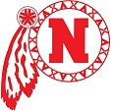**Saturday,August 29, 2015**

**8:00 a.m. – 11:00 a.m.**

**In the North High Cafeteria**

**$5 per person**

Football Scrimmage at 8:00 AM.

Parade across the 13th Street Bridge at 9:30 AM

Pep Rally on front lawn at 9:45 AM

Tennis, Volleyball & Soccer Scrimmages at 10:30 AM